**Distributed Systems**

Lab 2 - RPC

S Abhishek

AM.EN.U4CSE19147

**Part A**

**Recreate the RPC mechanism illustrated in the document for an implementing procedure to add two integers.**

Client:

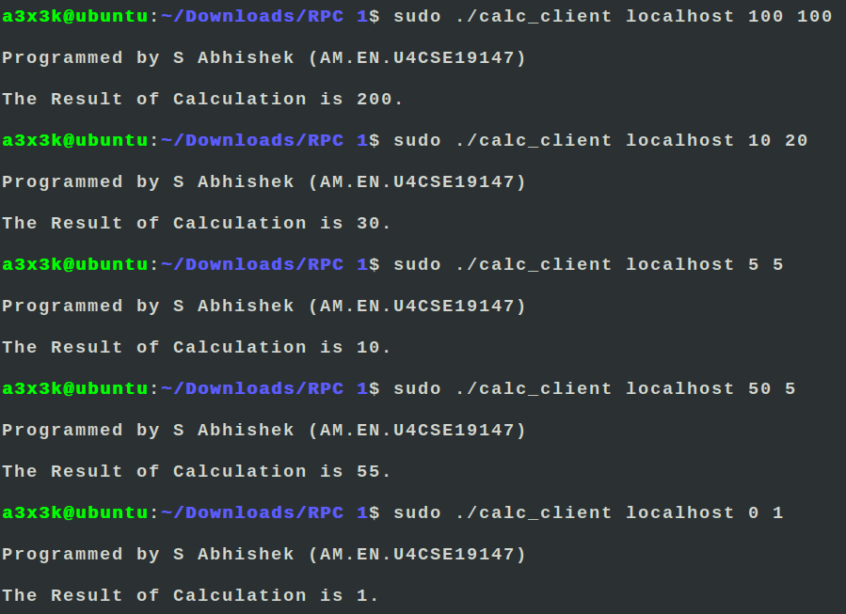

Server:

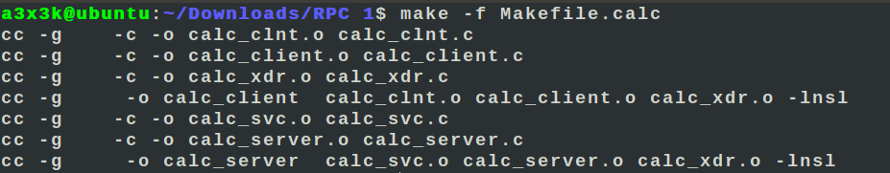

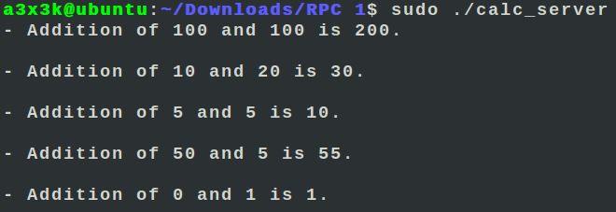

**Part B**

**a) Extend the application in Part A to form a basic calculator running on a remote server. As a bare minimum include additional procedures for the subtraction, division, multiplication. You can add more features as you wish.**

**b) The client should be able to select the operation to perform**

Client:

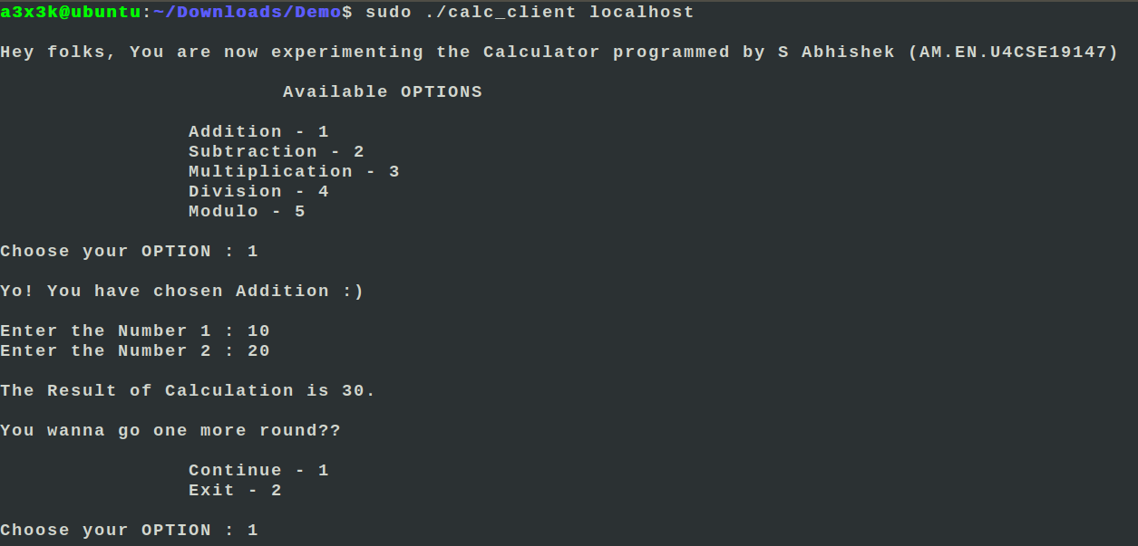

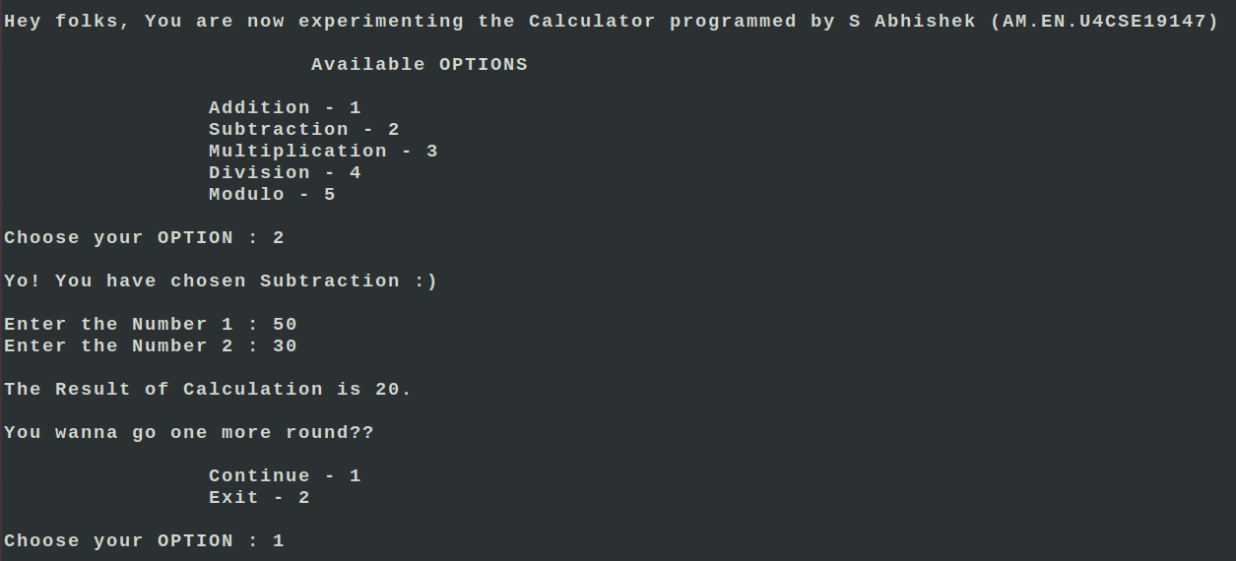

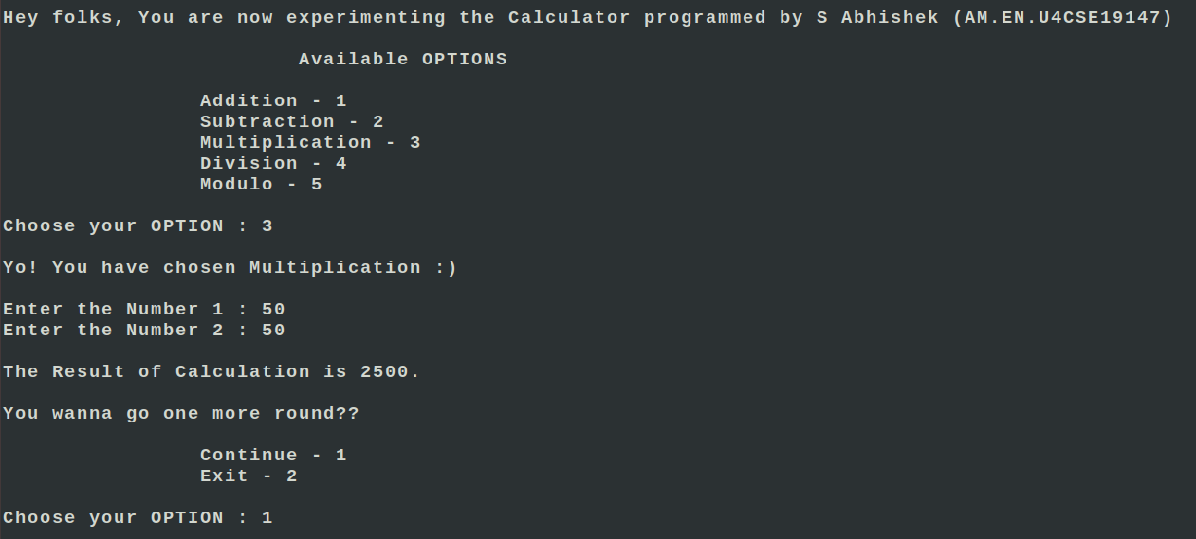

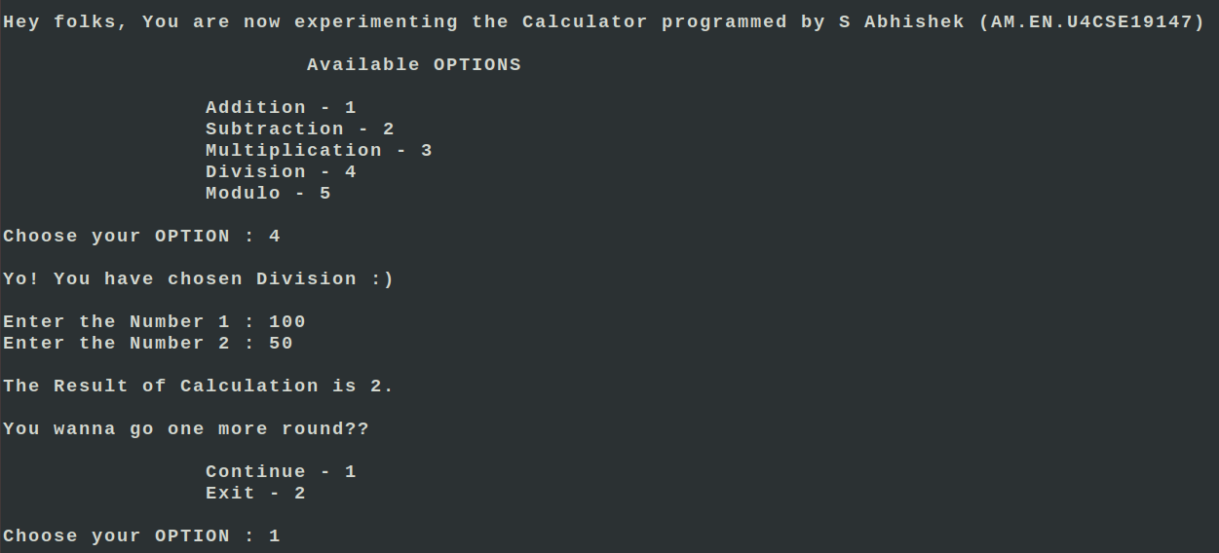

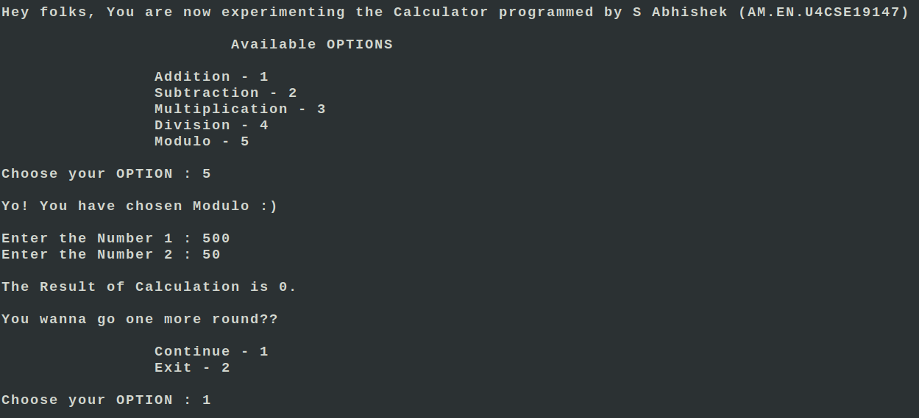

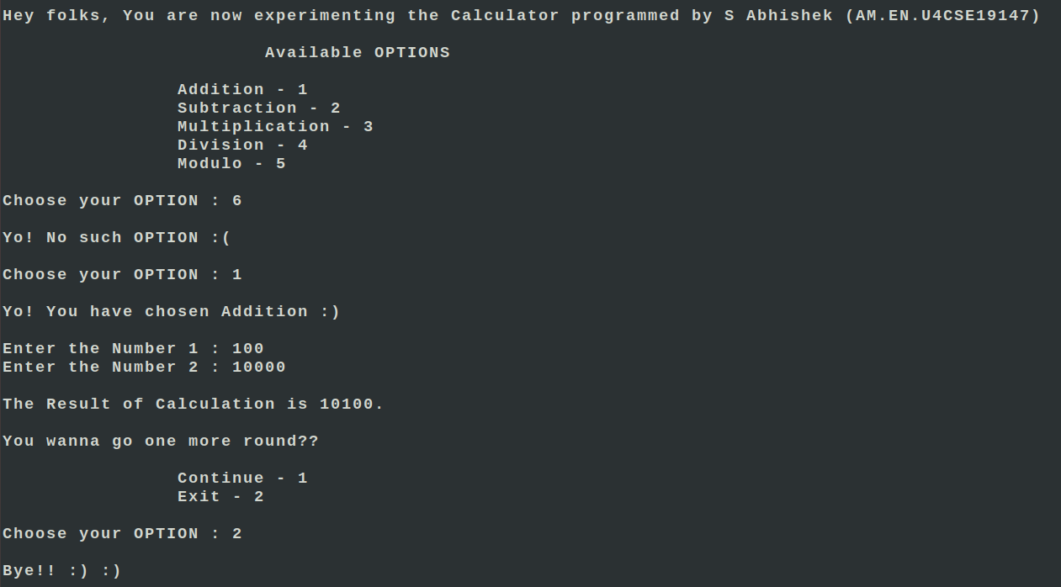

Server:

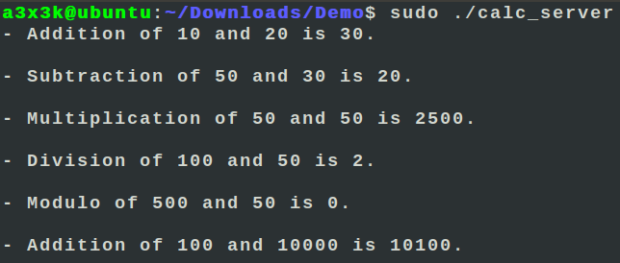

Thankyou!!